Sample Description of USBCANFD Python (x64)

by Chuangxin Technology

1.testing environment
The testing environment for this sample is:Win7/Win10/Win11 python3.8.8 64bit. Please refer to WIKI for specific installation of Python environment under Windows.
Note: The Python compiler is divided into 32-bit and 64-bit.
32-bit compilers need to use 32-bit DLLs in the directory:library\x86\ControlCANFD.dll
64-bit compilers need to use 64-bit DLLs in the directory:library\x64\ControlCANFD.dll

2. Program Introduction
Due to the specified DLL directory in the code "canDLL=windll. LoadLibrary ('./ControlCANFD. dll')" in the program, it is necessary to copy the DLL to the corresponding directory in order to run it: ControlCANFD.dll and the source code xx.py in the same directory.
Sample function: Two channels are initialized simultaneously: arbitration domain baud rate: 1M, data domain baud rate: 5M, CANFD adopts ISO mode, normal working mode. The sample defaults to sending 10 frames of data to the CAN2 channel and displaying it. This requires docking CAN1 with CAN2. The docking method is shown in Figure 1, and the test results are shown in Figure 2. V2.0 example added CAN transceiver and filtering settings.
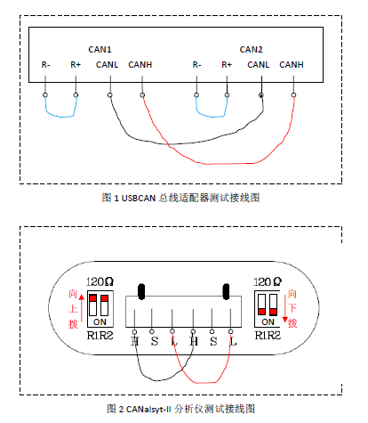
Figure 1. docking CAN1 with CAN2
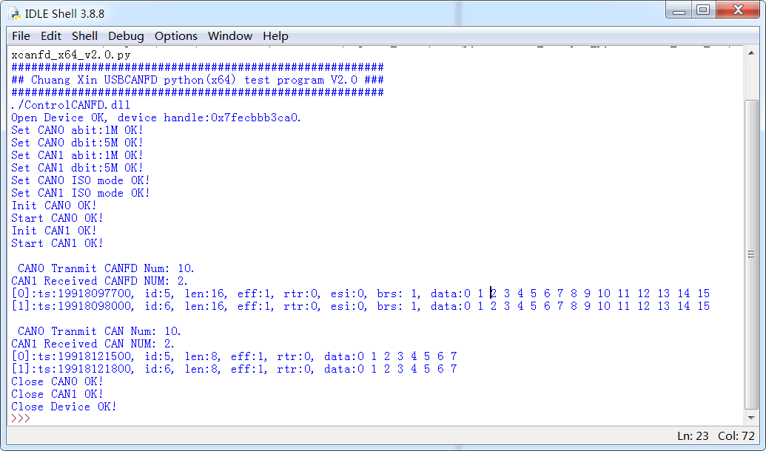
Figure 2. test result

